CMSC 204
Huffman Lab

- Create a Huffman Tree and generate the codes for each character of the following input:
create a huffman tree
For consistency:
- If same frequency – put in priority queue alphabetically; put space before other characters of the same frequency
- Add subtrees to end of group with same priority
- Lower number has higher priority (goes to front)

c-1 | r-2 | e-4 | a-3 | t-2 | space-3 | h-1 | u-1| f-2 | m-1 |n-1

c-1 | h-1 |m-1 |n-1 | u-1 | f-2 | r-2 |t-2|space-3| a-3 | e-4

Now encode “create a huffman tree”
0100000110101001110100101100010111101111111101101010111100001000110110

- Based on the following Huffman tree and binary sequence, what is the text

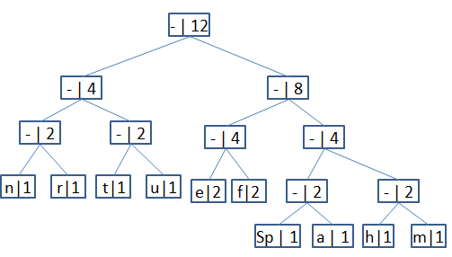

1110011101101111111010001100010001100100

Huffman tree

